South China University of Technology
《Course》Experiment Report
Experiment Title： The Design an Analysis of Computer Algorithms
Name： 张杰铖 Student ID： 202030443394
Class： 计科全英联合班 Group： Individual
Collaborator： NO
Teacher： 颜小洋
Description
【Objective and Requirement】
Objective：
Learn DFS, BFS, A* algorithms and branch-and-bound methods to solve eight-digit problems.
Requirement：
To implement the UI for the 8-puzzle problem with Four Strategies of Tree Search Algorithm (The simple game UI)
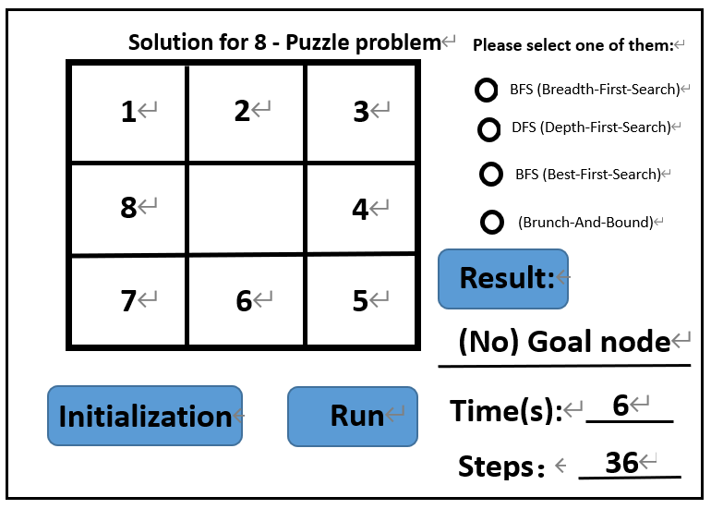
【Environment】
Operating System：Windows 10
Content
【Procedure】
Note: After I finished the whole lab, I heard that the teacher didn't want students to use Python to complete lab 6. Sorry I do use Python, but I'm not calling any of Python's existing libraries. Including the Linked-Queue of BFS, the Linked-Stack of DFS, the Heap of A* and other data structures are all implemented by C++. BFS, DFS, A* and Branch and Bound algorithms are also written for myself. The UI does not use some Python-specific GUI libraries, but uses QT to connect Python for use. The whole experiment is close to C++ except that the writing method is slightly different from C++.

- Step：
- Write an octal data structure. Write the DFS, BFS, A* algorithm and branch and bound method for the eight-digit problem. The A* algorithm is an algorithm that uses the priority queue to expand the optimal node with the number of state block coincidence as the objective function. The branch-and-bound method uses the Euclidean distance from the final state as the objective function to expand the optimal node with the priority queue, constantly finds a better solution and prunes other paths with the depth of the new solution as the lower-bound, and finally obtains the optimal solution. optimal solution algorithm.
- Write an eight-digit initialization function, and use the inverse number to determine whether it has a solution.
- Implement UI functionality.
- Result：
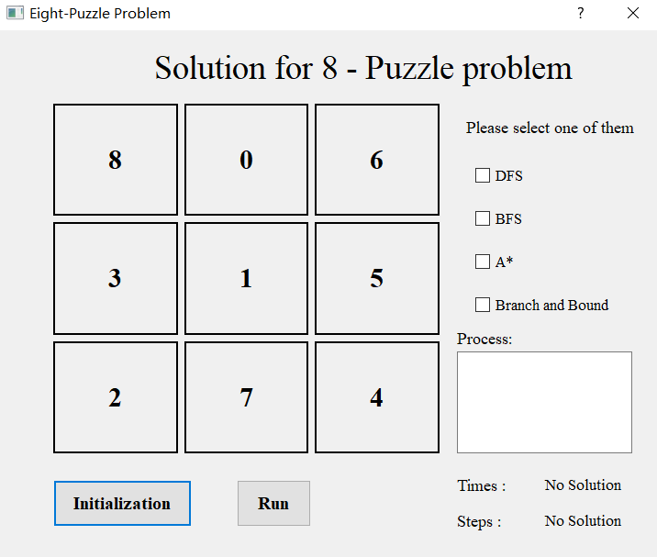
Click Initialize to re-initialize the eight digits. If there is no solution, the labels of Times and Steps will display no solutions. Otherwise, there is a solution.
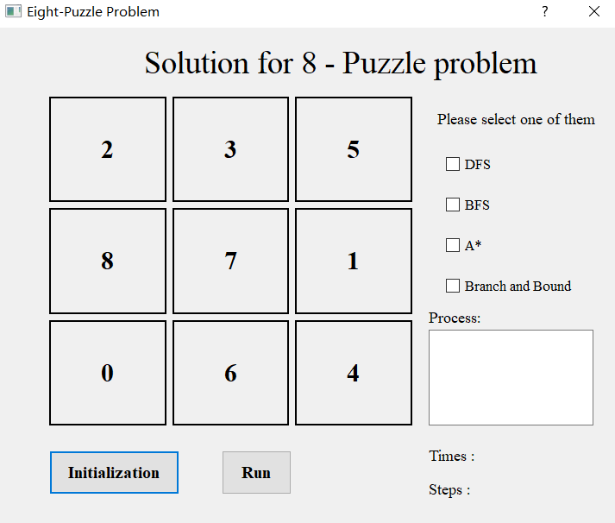
Select the DFS checkbox and click the run button. Times will record the time, Steps will record how many steps are used, and text edit will show the step-by-step process of getting the solution.
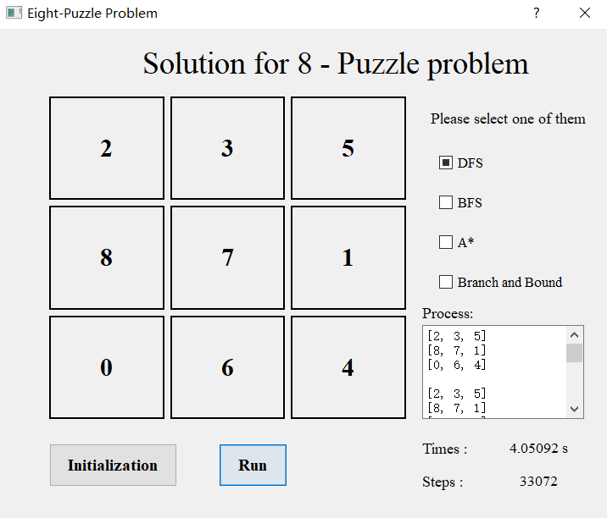
Select BFS and click the run button.
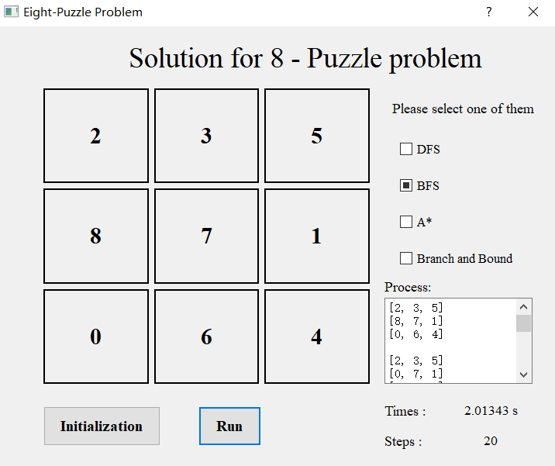
Select A* and click the run button.
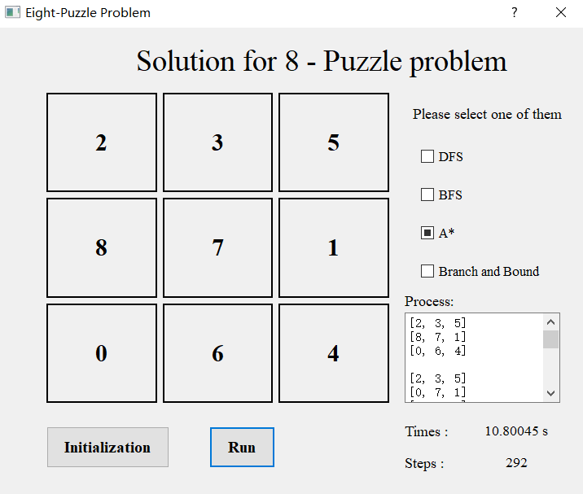
Select branch and bound and click the run button.
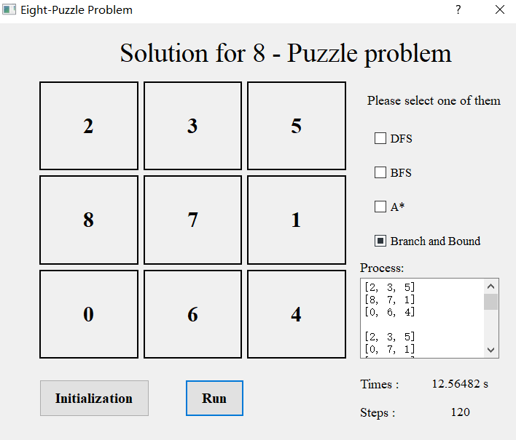

3. Program：
see attached.
Conclusion
Teacher’s Comments and Score
Comment：

Score： Signature：
Date：

